Peak Petroleum Industries Nigeria LTD

and

Equator Exploration Nigeria LTD

Offshore Nigeria Block OML 122

Bilabri D4

Appraisal Well

Revision 1

Well Plan Document

Drilling Unit

Semisubmersible Bulford Dolphin

Table of Contents

- Introduction
- Location Maps
- Basic Well Data
- Well Plan Outline
- Operation Summary
- Days vs Depth Curve
- Drilling Time Breakdown
- Rig Move
- Fracture Gradient / Pore Pressure
- Pressure Profile vs Depth
- Casing Program Summary
- Cement Program Summary
- Mud Program Summary
- Directional Survey Program Summary
- Formation Evaluation Summary
- Operational Procedures
Jetting 36” Conductor
Drilling 17-1/2” Hole Section Riserless
Setting 20” x 13-3/8” Surface Casing
Drilling 12-1/4” hole to 2600m

Signature Approvals:

Written By: ___________________________ Date: __________

Wali Adedotun
Junior Drilling Engineer – Beta Development Team

Reviewed By: ___________________________ Date: __________

Robert Montgomery
Drilling Project Manager – Beta Development Team

Approved By: ___________________________ Date: __________
Glyn Evans
Project Director – Beta Development Team

Approved By: ___________________________ Date: __________
Dr. Kenneth Seymour
Project Adviser – Beta Development Team

Approved By: ___________________________ Date: __________

Tony Gray or Bobby Roundtree
Drilling Superintendent – Beta Development Team

1. Introduction

This proposal for Bilabri D4 appraisal well is a modification of Peak’s original plan to appraise the Oil Rim in the C1.0 / C2.0 Reservoirs from a clustered surface location using deviated wells. The Bilabri D4 is now proposed to drill as a vertical well into the objective subsurface targets.

Bilabri Field is located in the northern portion of OML 122. The field was discovered in 1974 with only 4.5m of oil column (3m net) and 126m of gas in five reservoirs.

Peak’s first well, Bilabri D1, was spudded in November 2005 and confirmed an increase in oil column from 4.5m in Bilabri 1 to 21m (17m net) at the new Bilabri D1 location. The new well also proved at least one additional new reservoir of gas discovery. With these findings, the Bilabri Field has proved a minimum recoverable reserve of 26 – 50mmbls of oil and 615 – 1650 bcf of gas in two major producible reservoirs. Due to drilling difficulties and logging tool failures, the upsides in at least three other gas/condensate reservoirs are yet to be fully evaluated. The two main reservoirs, currently primed for appraisal and production, are the C1.0 and C2.0 Reservoirs. Oil has been proved in the C2.0 reservoir while the C1.0 has been penetrated in crestal GDT positions with its prognosed Oil Rim yet to be penetrated. The two reservoirs C1.0 and C2.0 are prognosed to be in communication.

Between November 2005 and September 2006, Peak Petroleum has drilled two (2) wells in Bilabri Field. The first well, Bilabri D1, had a combination of deep exploration objective and up-dip appraisal of the Hydrocarbon reservoirs previously penetrated in the Field. The second well, Bilabri D2, was a down-dip appraisal objective to locate an Oil Rim prognosed below the C1.0 Gas Cap.

Bilabri D3, previously planned as part of a cluster of side-tracks, is currently being drilled to test the unpenetrated Oil Rim prognosed in the C1.0 Reservoir. This is as a continuation of Peak’s appraisal drilling program in order to better understand the reservoir geometry and determine the most optimum drainage pattern to be drilled in the Field.

Bilabri D4, now being proposed, is specifically intended to penetrate the C2.0 Reservoir to appraise the westerly extent of the Oil Rim penetrated by Bilabri 1, Bilabri D1 and Bilabri D2 at the crest of the structure.

Details of the reservoir geology and trapping conditions are discussed in subsequent sections.

The Bilabri D4 well is proposed to be a vertical well with a TD of 2600m. The well is programmed for 25 days to drill and temporary suspend with the spud date scheduled to be in November 2006.

Logistics Base

Lagos, Nigeria will be the location of staff offices for the Beta Development Joint Operating Team. Port Harcourt will be the Operations Base to support the offshore operation. Onne Port will be the Supply Base with a one way sail time of +/- 18 hours for supply vessels to the rig and +/- 9 hours for the fast supply vessel.

Aero Contractors is the Helicopter Contractor who provides the Sikorsky S76C aircraft. The rig has a certified fueling station on board the rig and fueling is possible if required. Aero Contractors has an operational base in Warri where fueling will take place to aid in increasing payload trips to the rig.

Due to the Port Harcourt International Airport temporary shut down, all Expat personnel are transported from the Sam Mbakwe Airport, Owerri to the rig site via helicopter. All other passengers are loaded on the Sikorsky S76C in Port Harcourt at the NAF Base for transportation to the Bulford Dolphin offshore.

2. Location Maps

Regional Location Map

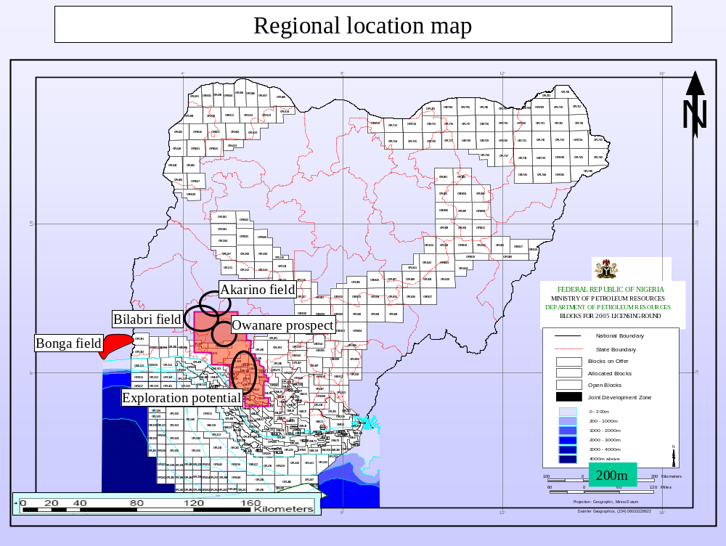

3. Basic Well Data

Well Name: Bilabri D4
Designation: Appraisal Well
Concession: OML 122
Depo Basin: Offshore Niger Delta
Offshore Field: Bilabri Field

Operator: Peak Petroleum Industries Nigeria LTD
Service Provider: Equator Exploration Nigeria LTD
Anticipated Spud Date: November 2006

Rig: Bulford Dolphin
Rig Contractor: Dolphin Drilling
Rig Type: Aker H3 Semisubmersible

Water Depth: 146 meters
RKB to Mean Sea Level: 25 meters
RKB to Mudline: 171 meters

Surface Location: X = 730,518.34 E

Y = 514,932.52 N

Lat: 04º 39’ 20.098” N
Long: 05º 04’ 40.689” E

Projection: UTM Zone 31N
Spheroid: WGS 84
Datum: WGS 84
Type: Transverse Mercator
Scale Factor: 1.00027
False Northing: 0.00 meters
False Easting: 500,000 meters
Zone 31

Objectives: Appraise Oil Rim in C2 Sand

Casing Setting Depths (RKB): 36” @ 255m (84m below mudline)
20” x 13-3/8” @ 825m (654m below mudline)
12-1/4” hole to 2600m TVD/MD

Programmed Days: 25 days to drill to TD of 2600m Vertical
And Temporary Abandon

Total Depth: +/- 2600m TVD/MD RKB

4. Well Plan Outline
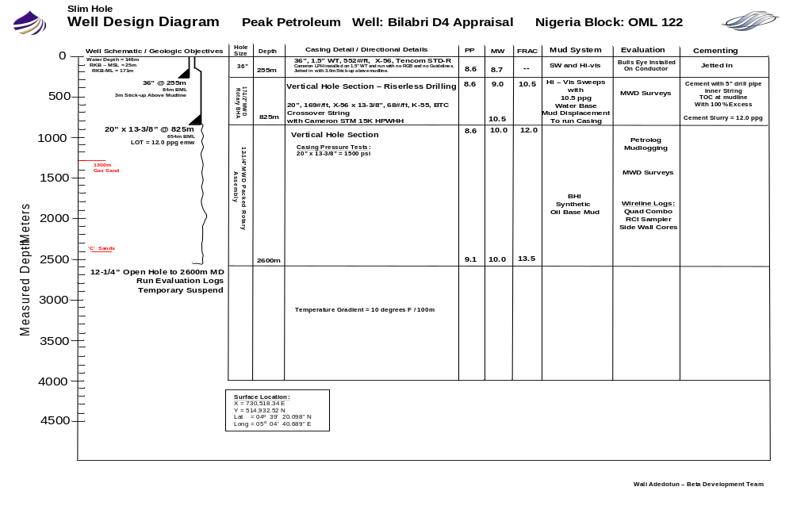

Well Profile Diagram
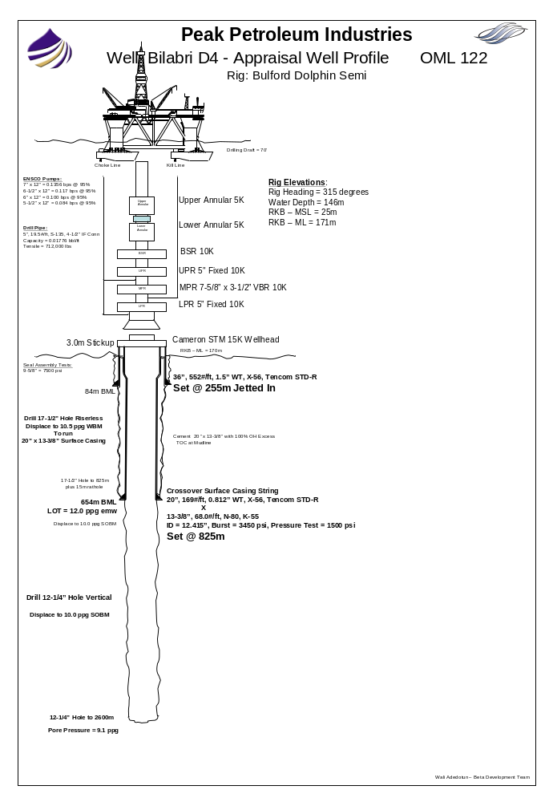

5. Operations Summary

Bilabri D3 Well Location Coordinates
The Bulford Dolphin Semi will be moved from the Bilabri D3 Well location to the Bilabri D4 Appraisal Well location using (2) AHTS vessels on contract to Peak/Equator. The anchors will be run as per Dolphin Rig Move Procedures with a proposed rig heading of 315 degrees. The water depth at the Bilabri D4 location is 145m – 147m.

The Bilabri D4 Surface Location Coordinates are as follows:
X = 730,518.34 East
Y = 514,932.52 North
Lat = 04º 39’ 20.098” North
Long = 05º 04’ 40.689” East

Setting 36” Conductor @ 255m RKB
The well will be spudded with a 36” Conductor / Jet String. The 36” Conductor String will be jetted to 255m RKB (84m below mudline) with a maximum hole angle of 1 degree with 3m stick-up above mudline. The conductor will be jetted using hi-vis sweeps made from guar gum and polymer and a jetting BHA Assembly consisting of a 26” bit and 9-1/2” OD Mud Motor. The conductor will be allowed to soak 4 to 6 hours before releasing the Cameron Running Tool and pulling the jetting BHA. The seven joints of 36”, 1.5” WT, 552#/ft, X-56, Tencom STD-R casing will be run with the Cameron Low Pressure Housing. No Retrievable Guide base or guidelines will be run. All efforts will be made to keep the 36” housing angle at 1 degree or less. If the casing is jetted in at an angle greater the 1.5 degrees, the conductor will be washed free and the conductor repositioned and re-spudded.

Setting 20” x 13-3/8” Surface Casing @ 825m RKB
The 17-1/2” hole section will be drilled with a 17-1/2” MWD Rotary Assembly. The hole section will be drilled riserless with returns to the mudline through the 30” LPH. The 17-1/2” hole will be drilled to 825m (depending on pipe tally plus 15m of rathole). The hole will be drilled riserless using hi-vis sweeps made from guar gum and polymer. The hole will be displaced to 10.5 ppg mud before running the 20”x 13-3/8” Casing. Cameron STM 18-3/4” 15K H-4 high pressure housing will be run with 2 joints of 20”, 171#/ft, 0.812” WT, X-56, Tencom STD-R and then crossed over to 13-3/8”, 68#/ft, K-55, BTC surface casing string. The casing will be cemented using a float shoe and collar - using a (2) joint shoe track above the float shoe. The casing will be cemented using 100% open hole excess on cement slurry volume with the TOC at mudline using 5” drill pipe inner string positioned 40m above the float collar during cement placement.

Drilling 12-1/4” Open Hole to 2600m TVD/MD RKB
The SS BOP will be run without guidelines or guide funnel. The ROV will assist in latching the H-4 connector on BOP to Cameron’s 18-3/4” HPH. The 20” x 13-3/8” casing will be pressure tested to 1500 psi before drilling out. The casing will be displaced to 10.0 ppg SOBM and drilled out using a slick 12-1/4” BHA. A LOT will be performed to 12.0 ppg emw. The slick assembly will be pulled. A rotary assembly with MWD will be run in and the 12-1/4” hole section will be vertically drilled to 2600m RKB. The mud weight will be controlled as required to maintain hole stability and limit overbalance to formation pressure. The well will be temporarily suspended for later re-entry.

6. Days vs. Depth Curve
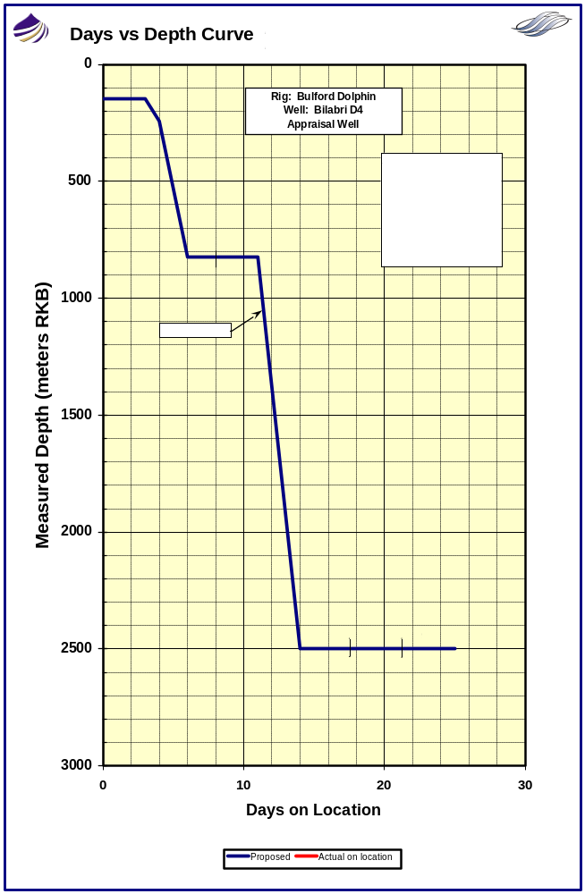

7. Drilling Time Breakdown

Operation Activity | Days | Cum Days
Jet in 36" Conductor. Set 20" x 13-3/8" Surface Casing.
Move "Bulford Dolphin Semisubmersible" to location and confirm position. | 1.0 | 1.0
Run anchors and pre-tension. Ballast to drilling draft. | 2.0 | 3.0
Spud Well. Jet in 36", 1.5" WT Conductor at 255m. Release Cameron Running Tool. POOH. | 1.0 | 4.0
Drill 17-1/2" hole section riserless to 825m. Displace to 10.5 ppg WBM. Wiper Trip. POOH. | 2.0 | 6.0
Set 20" x 13-3/8" Surface Casing w/ 18-3/4" Cameron HPWHH. WOC. POOH w/ RT. | 1.5 | 7.5
Run and test 18-3/4" BOP stack. | 1.5 | 9.0
Drill out 20" x 13-3/8" casing. Displace to SOBM. LOT. POOH. | 1.0 | 10.0
Total Days | 10.0
Drill 12-1/4" Evaluation Hole to 2600m.
MU 12-1/4" MWD Rotary BHA. RIH. | 1.0 | 11.0
Drill 12-1/4" Vertical Hole from 825m to 2600m MD (1775m @ 25m/hr). | 3.0 | 14.0
Condition hole to run Baker Atlas Open Hole Logs. POOH with LWD BHA. | 1.0 | 15.0
RU Baker Atlas. Run Open Hole Evaluation Logs. (Quad Combo, RCI Fluid Sampler, and SWC). | 3.0 | 18.0
Total Days | 8.0
Plug Back Open Hole. Temporary Suspend.
RIH with 5" Drill Pipe. Circulate and condition mud. | 1.0 | 19.0
Set Cement Plugs for Temporary Abandonment. Displace to WBM. | 3.0 | 22.0
Pull SS BOP. LD Drill Pipe. Pull Anchors. Release Rig. | 3.0 | 25.0
Total Days | 7.0
Total Days on Well |  | 25.0

8. Rig Move

The contracted AHTS vessels will move the Bulford Dolphin Semi from the Bilabri D3 location. Fugro navigation equipment and personnel on board the rig will be utilized to verify the rig’s final position at Bilabri D4 Location. The rig’s final heading will be positioned at 315 degrees. (To be verified with Dolphin’s OIM).

Bilabri D4 Well Surface Location Coordinates:

X = 730,518.34 E

Y = 514,932.52 N
Lat: 04º 39’ 20.098” N
Long: 05º 04’ 40.689” E

Other Well Locations in the Anchor Handling Pattern of the Bulford Dolphin:

Actual Location – Bilabri D2

X = 730,698.61 E

Y = 514,847.21 N
Lat: 04º 39’ 17.304” N
Long: 05º 04’ 46.529” E

Actual Location – Bilabri DX1

X = 731,054 E

Y = 514,480 N
Lat: 04º 39’ 05.3182” N
Long: 05º 04’ 58.0213” E

The water depth at the Bilabri D4 location is 146 meters. An 8-point mooring system will be utilized. The rig move will be based on the Dolphin Rig Move Procedure. The Dolphin Barge Captain will decide the running order of the anchors as per the Rig Move Procedure and after discussion with the captains of the anchor handling vessels and Peak Drilling Supervisor.

Anchors are to be tensioned to Dolphin specifications after adequate soak time is allowed. Experience from offset wells indicates that anchoring will not be a problem.

A meeting will be held with workboat captains and with Dolphin rig personnel on anchoring procedures.

Crews on board the workboats will enable a full 24 hour anchoring operation to be carried out.

Send in Fugro Preliminary Position Report to PHC and Lagos Office, once anchored up, and at final spud position. Attempt to position the rig to within 3 meters of proposed surface location.

A site survey has been performed and no shallow gas risks have been identified. No seabed obstructions identified apart from the above mentioned wells.

After the rig has run anchors and ballasted down, the ROV will perform a seabed survey of 100 meters around the proposed well location.

Anchoring operations description in the Daily Drilling Report should state the following times:
PCC passed to boat, anchor on bottom, PCC passed back to rig.

Anchoring Pre-Tension Value should also be reported.

9. Fracture Gradient / Pore Pressure

Normal Pore Pressures are expected down to TD.

It is anticipated that the following casing shoe leak-offs will be achieved
(all depths are meters RKB):

Shoe Depth | Hole Size (in) | Hole TD  (m TVD/MD) | LOT (ppg) | MW  (ppg) | Pore Pressure (ppg)
20” x 13-3/8”  @ 825m | 17-1/2” | 825 | 12.0 | 10.5 | 8.6
-- | 12-1/4” | 2600 | -- | 10.0 | 9.1

10. Pressure Profile vs Depth
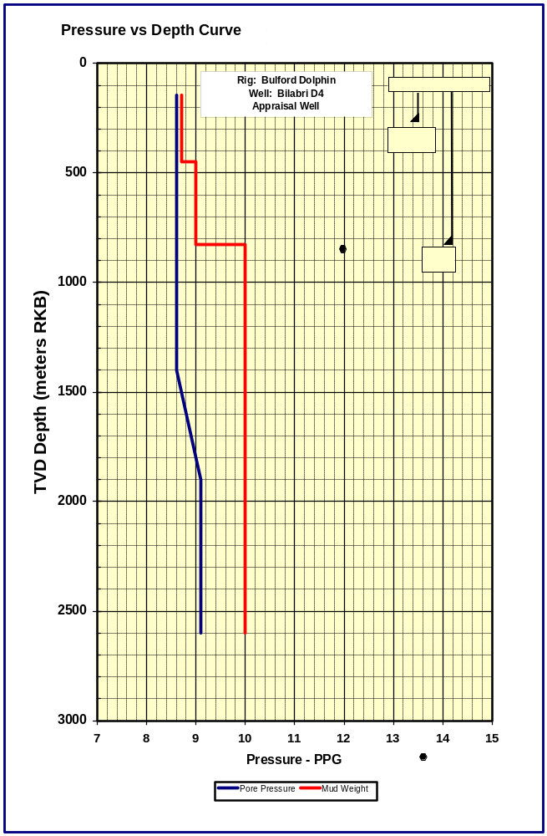

11. Casing Program Summary

The following table provides a summary of the selected casing setting depths and material specifications.

Casing Size (in) | 36” | 20” | 13-3/8”
Weight (#/ft) | 552 | 169 | 68.0
Grade | X-56  1.50” WT | X-56  0.812” WT | K-55
Connection | Tencom STD-R | Tencom STD-R | BTC
Make up Torque (ft-lbs) | Min – 36,000  Max – 40,000 | Min – 19,000  Max – 22,000 | To Mark
Connection OD / ID | 36.81” / 31.75” | 21.0” / 18.25” | 14.375” / 12.415”
Setting Depth (m MD) | 255 | 2 Joints + Crossover Joint | 825
Burst (psi) | -- | 3910 | 3450
Collapse (psi) | -- | 2500 | 1950
Tensile x 1000 lbs | -- | 2692 | 1069

Notes:
- 20” x 13-3/8” Surface Casing run with Cameron 18-3/4” HPH
- 30” wellhead extension is 1.5” WT with Tencom STD-R Connections
- The casing design factors comply with the following minimum safety factors:
Collapse SF = 1.0
Burst SF = 1.1
Tensile SF = 1.6

12. Cementing Program Summary

36” Conductor @ 255m RKB
Jetted in with 84m mudline penetration. Allow for +/-6 hours soak time.

20” x 13-3/8” Surface Casing @ 825m RKB
Casing Size: 20”, 169#ft, X-56 x 13-3/8”, 68#/ft, K-55, BTC
Setting Depth: 825m (654m below mudline)
Top of Cement: Lead – Mudline
Tail – 150m above 13-3/8” shoe
Cement Weight: Lead - 12.0 ppg
Tail – 15.6 ppg
Cement Yield: 15.5 cu ft/sx
Open Hole Excess: 100%
Cementing Details:

Cement with 5” drill pipe inner string 40m above 13-3/8” float collar
Run (2) joint shoe track
Do not run Bow Type Centralizers
Displace TOC to 20m above 13-3/8” float collar
Use 50 bbls of Seawater Spacer before cement
Paint 13-3/8” shoe joints to aid in ROV observation

Paint and stripe 20” HPWHH to aid ROV observation
Use a drill pipe wiper dart to displace cement thru the 5” drill pipe cement stinger
Use water base mud to displace cement.

BJ Cement Lab tests will be sent to rig before any cement job.

A program will be issued for any other cementing operations which are required.

13. Mud Program Summary

Hole Section | Mud System | Fluid Properties | Comments
36”  Jetted | Seawater +  Hi-Vis Sweeps | Mud Weight: 8.7 ppg  Viscosity: >80 sec/pt  Yield Point: >50 lbs/100 ft² | Due to a shortage of Bentonite in Nigeria, Guar Gum and XCD Polymer will be used to build the Hi-vis mud volumes.  Pump 2x50 bbls each stand or as required.  Spot 50 bbls on connections or as required.  After circulating 36” conductor clean at TD, displace 36” conductor with Hi-Vis before waiting on soak time.
17-1/2”  Riserless | Seawater +  Hi-Vis Sweeps | Mud Weight: 8.7 ppg  Displace to 10.5 ppg WBM  Viscosity: >100 sec/pt  Yield Point: >50 lbs/100 ft² | Due to a shortage of Bentonite in Nigeria, Guar Gum and XCD Polymer will be used to build the Hi-vis mud volumes.  Pump 2x50 bbls each stand.  Spot 50 bbls on connections.  Spot +/-820 bbls of 10.5 ppg spud mud in open hole before running 20” x 13-3/8” Casing.  Caustic Pills were used on Bilabri D3 well to free the stuck BHA in the 17-1/2” hole below the conductor.  If stuck pipe is experienced in the 17-1/2” hole section, spot 50 bbls of Caustic at the bit. Let soak while working pipe.
12-1/4”  Open  Hole | Para Drill System  Synthetic Oil Base Mud | Mud Weight: 10.0 ppg  Funnel Vis: 45-55 sec/qt  PV: 25 – 30  YP: 20 – 25  HPHT: <3  OWR: 75 / 25  ES: > 400  % Water: 25% | Para Drill utilizes a low toxicity mineral oil PARA-TEQ as a base fluid.  Follow BHI procedures on displacement to SOBM.  Rheological properties should be maintained within operational limits and careful attention paid to hole cleaning while drilling section.  Pump Hi-Vis Sweeps as required or as per BHI recommendation.  Ensure caution before pumping LCM or Hi-Vis Sweeps as not to interfere with LWD Performance.

14. Directional Survey Program Summary

Hole Size | Survey Type | Frequency
36” Jetted | Totco Instrument  And Bulls Eye on Conductor Body | As Required
17-1/2” | MWD | Every 5th Connection
12-1/4” | MWD | Every 5th Connection

15. Formation Evaluation Summary

Baker Atlas Wireline Logs to be run in the 12-1/4” Hole as follows:

1. Quad Combo
2. RCI Sampler to take pressure readings and samples
3. Sidewall Cores

No open hole cores will be taken in this well.

MudLogging
A fully computerized PetroLog Mudlogging Unit staffed by two data engineers, 1 ADT, and two sample catchers will be fully rigged up before drilling out of the 13-3/8” Surface Casing.

Sample Interval
Samples are to be taken every 10m from casing shoe down to the top of reservoir sections and at 3m intervals thereafter to the 12-1/4” Hole Section TD. The sampling intervals are to be followed unless the Wellsite Geologist decides that operational procedures dictate otherwise. Spot samples will be taken at the request of the Wellsite Geologist.

Wet Cuttings Samples
Five (5) sets of unwashed wet cuttings should be collected in plastic lined cotton bags.

Washed and Dried Samples
Four (4) sets of washed and dried cuttings should be collected in paper envelopes.

Check with Peak Petroleum Office in Lagos as to the cutting sample requirements for Nigerian DPR Authority and gas sample analysis.

16. Operational Procedures

Jetting in 36” Conductor

Operation Summary
- Position 36” by use of Fugro Positioning to within 3m of proposed surface location.

- Pick up and jet in 36” conductor with 30” LPH using a 26” bit and mud motor jet string run on Cameron 30” running tool to 255m with 3m stickup above mudline (depending on strap of 36” pipe).

- Pump at minimum flow rate while jetting the first 15m below mudline.

- Allow 36” Conductor to soak 4 to 6 hours before releasing 30” running tool.
Notes:
Rig Elevation: RKB to MSL = 25m
RKB to ML = 171m
Penetration Below Mudline = 84m
Stick-up Above Mudline = 3m
Drilling Fluid: Seawater with Polymer Sweeps
Inclination: ROV to observe bulls eye installed on body of 36” which will be
located +/- 1m below 30” LPH and slope indicator installed above the
Cameron 30” running tool.

General Procedure
- Lay out and strap (7) joints of 36” casing on deck. Note the sequence of joints to be run are labeled as the strength of the pad eyes. Measure BHA components to allow space out of the 26” bit to be a distance of +/- 6 to 8 inches below the bevel on the bottom joint of 36” casing. Paint bottom 10m of shoe joint white with black stripes. Paint the top housing joint with black stripes on white background in 1m lengths from top of 30” housing for 10m. Number each black strip 1 thru 10. Paint top connection of the Cameron running tool white and stripe black to aid in visual indication of release by ROV – remove all bull plugs in running tool. Apply grease in areas of running tool so as to keep clear of sand/debris during jetting. Consult with Cameron Engineer. Install bracket and frame to allow a 5 Degree Bulls Eye Slope Indicator to be installed below the Cameron 30” Low Pressure Housing. Paint 26” Bit, Bottom of Mud Motor, and inside of 36” bevel shoe yellow to allow observation of bit space out with ROV. Change pump liners to 7” on all three mud pumps.
36” Conductor String (Top Down)
30” Cameron Low Pressure Housing Joint with Tencom STD-R Pin Down
6 Joints of 36”, 1.5” WT, 552#/ft, X-56, Tencom STD-R Box Up x Pin Dn
1 Joint of 36”, 1.5” WT, 552#/ft, X-56, Tencom STD-R Box x Bevel Down
Rack back the Cameron 30” Wellhead Running Tool in derrick – Remove all bull plugs from running tool and service running tool as per Cameron Engineer.

Rack back in derrick the following jetting BHA:
26” Jetting Assembly (Bottom Up)
26” RR Rock Bit jetted with 3 x 20/32nd + 1 x 30/32nd nozzles
9-1/2” OD PDM Mud Motor with 0 degree bend
26” String Stabilizer
9-1/2” OD Drill Collar
Crossover: 7-5/8” Reg Pin x 6-5/8” Reg Box
8” OD Drill Collar
8” OD Pony Drill Collar if required
Crossover: 6-5/8” Reg Pin x 4-1/2” IF Box
5” Drill Pipe
Drill pipe pup joints as required
Cameron 30” Running Tool
** Use 5” HWDP as landing string above Cameron Running Tool **
- Rig up to run 36” using pad eyes with slings and shackles. Remove rotary table insert and use ‘C’ plate. Make up 36” with bull tongs. Cut pad eyes off using cutting torch. Record weight of 36” Conductor String when landing last joint in rotary on ‘C’ Plate.
Recommended Torque for 36” Tencom STD-R
Maximum – 40,000 ft lbs
Minimum – 36,000 ft lbs
- Rig up false rotary on ‘C’ plate installed on top of Cameron 30” LPH. Run 26” jetting assembly inside casing – Be sure to check torque on all connections to avoid back off of jet string due to reactive torque of mud motor. Record BHA weight when pick up Cameron 30” running tool. Engage 30” LPH and space out BHA and jump ROV to ensure 26” bit is 6” to 8” below bevel of 36” shoe.
- Pick up entire jetting assembly and casing. Cut off top pad eyes and record entire weight of 36” Conductor / Jet string. Install bracket and Bulls Eye Slope Indicator when 30” LPH is in moonpool area using rig welder.
- RIH and space out above mudline. Ensure space out allows for full stand penetration so as not to pull conductor shoe above mudline when making first connection. Jump ROV to observe bulls eye slope indicator position.
- Start and roll-over pumps to prevent plugging bit – tag mudline and record water depth measurement and full weight of jetting assembly. Paint mark on drill pipe to record mudline depth at rotary. Measure drill pipe using meter stick to monitor and measure jetting operation. Lock rotary and Top Drive to ensure no rotation. Slack off and free fall for +/- 5 meters with maximum 5K WOB. Fugro confirm preliminary spud location coordinates and send Fugro Document to Lagos and PHC.

- Increase pumps to 30 spm. ROV observe top of running tool to check returns and slope indicator. Attempt to maintain less than 1 degree on slope indicator.
- Jet in 36” to 255m RKB = 84 meters below mudline:
a. Ensure penetration rate of conductor is same as drill pipe to ensure
the drill pipe is not bowing.
b. Jet casing in with seawater and 50 bbls Hi-Vis sweeps every
12m jetted. Pump additional sweeps if required.
Maintain adequate flowrate to ensure returns are up the casing.
c. Monitor Bulls Eye Slope indicator after jetting 15m.
d. Use the minimum pump rate of +/-300 gpm that allows penetration
while jetting the first 15m below mudline to prevent washing
out the seabed. Gradually increase pump rate.
- Use an absolute maximum of 24,000 lbs of weight while jetting the first 15m. Keep the 5” HWDP landing string in tension and only use 85% of 36” buoyed weight BML to jet the pipe in place (see chart for recommended max weights versus jetting depth). Gradually reduce the pump rate when approaching the planned shoe depth.

Depth BML - mtrs | Buoyant Weight - lbs | 85% of Buoyant Weight - lbs
15m | 24,000 | 20,400
30m | 47,000 | 39,950
45m | 71,000 | 60,350
60m | 94,000 | 79,900
75m | 118,000 | 100,300
84m | 132,000 | 112,300

- If possible, do not work pipe over last joint jetted in.
- After jetting 36” in place, pump 100 bbls of Hi-Vis and circulate out to clear cuttings from inside of 36” string. Displace 36” with +/-300 bbls of Hi-Vis.
- When at TD, support casing weight for 6 hours to allow skin to form. Monitor Bulls Eye Slope Indicator and length of stick-up above mudline. Report on DDR. Slack off slowly to neutral weight (do not include weight of jetting string) and observe if there is slippage for (1) hour. Release Cameron Running Tool and POOH with jet string. Lay down same. Make final Fugro Position Report and send to Lagos and PHC. Record RKB to 30” LPH and note on DDR.

Setting 20” x 13-3/8” Surface Casing - Riserless

Operation Summary
- RIH and make entry into 30” LPH with 17-1/2” rotary drilling assembly with ROV assist. Drill out 36” Conductor using seawater and Hi-Vis sweeps.

- Drill 17-1/2” hole section riserless to 825m shoe depth plus 15m of rathole. Monitor returns to 30” housing with ROV. Sweep hole clean at TD. Condition hole to run casing by backreaming to 36” shoe using seawater and Hi-Vis sweeps. Displace open hole with 10.5 ppg Water Base Mud.

- Run 20” x 13-3/8” Surface Casing String with 5” inner cementing string spaced out to 40m above 13-3/8” float collar. Make entry into 30” LPH with ROV assist. Land and latch Cameron 18-3/4” HPH into 30” housing.

- BJ cement 20” x 13-3/8” Surface Casing with 12.0 ppg ‘G’ lead slurry to mudline and 150m of 15.6 ppg tail slurry above 13-3/8” shoe. Release Cameron 18-3/4” Running Tool. POOH with running tool and 5” drill pipe stinger.

- Run SS BOP and Riser without guidelines or guide funnel. Use ROV assist.

Rig Elevation: RKB to MSL = 25m
RKB to ML = 171m
Penetration Below Mudline = 654m
Drilling Fluid: Seawater with Polymer Sweeps. Displace to 10.5 ppg before running
20” x 13-3/8” Surface Casing.
Inclination: Take MWD surveys every 5 stands drilled. ROV to monitor Bulls Eye Slope Indicator on 36” conductor.

General Procedure – Drill 17-1/2” Hole Riserless
- Make up the following 17-1/2” MWD Rotary Drilling Assembly:
17-1/2” RR Rock Bit – Type HTC MXL1 with 3x20/32nd nozzles
Bit Sub
9-1/2” OD Drill Collar
17-1/2” IB Stabilizer
9-1/2” OD Drill Collar
17-1/2” IB Stabilizer
Float Sub with Solid Float
Crossover
Pin/Pin Sub
8-1/4” OD MWD Tool
8-1/4” OD NMDC
(4) 8” OD Drill Collars
7-3/4” Drilling Jars
8” OD Drill Collars
Crossover
(18) 5” HWDP
Note:
Paint Bit and Bottom of BHA yellow to aid in ROV observation.
Paint Mark on Drill String to show when bit is at 825m TD. This will allow
ROV to confirm depth of bit by visual check of mark at 30” housing.

- RIH to 30” LPH with 17-1/2” MWD Rotary Assembly. Make entry into housing with ROV assist.
- Drill 17-1/2” hole riserless to 825m plus 15m of rathole. Ensure all Shallow Gas Procedures are in place as per Dolphin Requirements. Use seawater at max rate and pump 50 bbls Hi-Vis every mid stand drilled and spot 50 bbls on bottom during connections. Take MWD surveys every 5 stands drilled.
- Sweep hole clean. Backream to 36” shoe using seawater and Hi-Vis Sweeps as required. Run back to bottom. Displace hole with +/-820 bbls of 10.5 ppg Water Base Mud before pulling out of hole to run casing. Ensure caution when tripping. Backream with seawater if hole is tight. It may be necessary to rebuild 10.5 ppg mud after pulling BHA above the 36” shoe – having enough mud volume to condition hole riserless is a critical factor. Spend time to build mud volume before tripping back to bottom.
- POOH and prepare to run 20” x 13-3/8” Surface Casing.

General Procedure – Running 20” x 13-3/8” Surface Casing Riserless
- Make up Cameron 18-3/4” High Pressure Housing with running tool. Ensure Nominal Seat Protector is installed. Rack back in derrick. BE SURE TO USE DERRICK FINGER WHICH IS CLOSE TO TOP DRIVE – THIS WILL LIMIT THE DIFFICULTY WHEN LATCHING THE ELEVATORS ON THE LANDING STRING WHEN PICKING UP THE HOUSING STAND.
- Make up the following 20” x 13-3/8” Surface Casing String (from bottom up):
13-3/8” Double Valve Float Shoe
13-3/8”, 68#/ft, K-55, BTC Jt thread locked to float shoe
13-3/8”, 68#/ft, K-55, BTC Casing Joint
13-3/8” Double Valve Float Collar
13-3/8”, 68#/ft, K-55, BTC Jt thread locked to float collar
13-3/8”, 68#/ft, K-55, BTC Casing - As Required
13-3/8” x 20” Crossover Jt: 20” Tencom STD-R Box Up x 13-3/8” BTC Pin Down
(2) Joints 20”, 169#/ft, X-56, Tencom STD-R Box x Pin
18-3/4” Cameron High Pressure Housing with Tencom STD-R Pin down
18-3/4” Cameron Running Tool

Notes:
-Paint btm joint of 13-3/8” yellow with black stripes to aid ROV observation
-Paint top of 18-3/4” housing with black stripes against white background. Measure top 10m of Housing to have paint stripe every meter and labeled 1 thru 10.
-Do not run 13-3/8” centralizers.
-Run 5” Inner Drill Pipe Cement String attached to Cameron Running Tool to 40m above 13-3/8” Float Collar.
-Thread Lock bottom 3 joints of 13-3/8” casing.
-Run (2) joint shoe track.
-Cement with 100% Open Hole Excess with top of lead cement at 30” Housing. Cement shoe with 150m of Tail Cement using 100% Open hole excess.

-Displace cement using 10.5ppg mud to within of 20m above 13-3/8” float collar.
-Torque Requirements for 20” Tencom STD-R:
Max = 22,000 ft lbs Min = 19,000 ft lbs
- Rig up Weatherford Casing Crew. Run 13-3/8” casing with sidedoor elevators to mudline. Check circulation of float equipment. Make shoe entry into 30” LPH with ROV assist. Before making shoe entry into open hole below 36” shoe, rig up to use spider elevators and Weatherford fill-up tool to have the option to wash casing down if required. Use 10.5 ppg mud if required for washing down casing. Fill casing with 10.5 ppg mud every 5 joints run.
- After running all 13-3/8” casing, pick up 20” x 13-3/8” crossover joint using sidedoor elevators. Run (2) joints of 20”, 169#/ft, X-56, Tencom STD-R casing. Pick-up Cameron 18-3/4” High Pressure Housing with running tool (ensure NSP is installed in housing). Remove running tool.
- Rig up plate with false rotary on top of 18-3/4” HPH. Run 5” drill pipe inner string to within 40m above the 13-3/8” float collar.
- Make up Cameron Running tool to 5” drill pipe inner string. Pack grease in areas of running tool and lock ring to keep debris out of tool. Engage Running Tool as per Cameron Engineer Instruction. Record weight of casing and inner string.
- Run Casing String to latch in the 30” LPH. Ensure ROV observes the casing penetration at the mudline as the blocks are slacked off – so as not to bow drillpipe landing string if tight hole is experienced. Take 50K over pull. Break circulation with seawater. Circulate with seawater to displace 10.5 ppg WBM out of 13-3/8” x 17-1/2” annulus.
- BJ mix and pump 50 bbls of seawater spacer. Mix and pump 12.0 ppg lead slurry using 100% open hole excess with TOC at 30” LPH and 150m of 15.6 ppg tail slurry above 13-3/8” shoe.
- Displace cement to 20m above top of float collar with drill pipe wiper dart and 10.5ppg mud using BJ cement unit. Bleed off and check floats. WOC on 6 hours. ROV monitor 18-3/4” x 30” annulus while WOC.
- Release Cameron 18-3/4” running tool. POOH with running tool and 5” drill pipe inner string. Wash wellhead area with end of cement string above 18-3/4” housing using seawater at high flowrate. Continue to POOH. LD running tool.
- Move rig off location. Run SS BOP and Riser. Use caution to land and latch BOP on 18-3/4” H-4 connector due to no funnel being installed on the BOP H-4 connector. Move rig using anchors very slowly, monitor movement with ROV assist. Monitor BOP position over wellhead with ROV to allow BOP movement to be stationary. Ensure adequate time is taken to move rig back on location and that no damage is done to either connector.
- Latch the H-4 connector. Confirm latch with 50K overpull. Pressure test H-4 connector to 1000 psi after latching.
- Pressure test Choke & Kill lines on double joint of riser above stack, midway, and at slip joint. Run Cameron Test Plug and pressure test BOP components to 350 psi / 3000psi for 5 / 10 minutes.
- Prepare for SOBM displacement during the drill out of the 13-3/8” surface casing.

Drilling 12-1/4” Vertical Hole Section to 2600m TVD/MD

Operation Summary
- RIH with slick 12-1/4” BHA. Drill out 13-3/8” shoe track. Displace to 10.0 ppg SOBM. Perform LOT at 13-3/8” shoe – Expected LOT = 12.0 ppg emw. POOH with slick assembly.

- Make up 12-1/4” MWD Packed Rotary Assembly. Drill 12-1/4” hole section to 2600m hole. Maintain 10.0 ppg SOBM. Take MWD surveys every stand drilled. Condition hole to run open hole logs.
Drilling Fluid: SOBM at 10.0 ppg.
Inclination: Take MWD surveys every stand drilled.

General Procedure – Drill 12-1/4” Open Hole
- Make up 12-1/4” Slick BHA. RIH to tag TOC. Space out and pressure test 20” x 13-3/8” casing to 1500 psi for 15 minutes with BJ cement unit.
- Clean pits. Take on 10.0 ppg SOBM from work vessel. Change to 6-1/2” pump liners on all (3) mud pumps.
- Drill out 13-3/8” shoe track using seawater with high vis sweeps taking returns overboard. Drill out to within 2m of float shoe. Displace well to 10.0 ppg SOBM. Take CLFP and SCR’s.
- Continue drill out 13-3/8” float shoe and clean out 17-1/2” rathole. Circulate hole clean. Pull bit above 13-3/8” shoe.
- Perform LOT using BJ cement unit. Close MPR and pump down top drive at ¼ bpm. Anticipated LOT = 12.0 ppg emw.
- After successful LOT. POOH with slick BHA.
- Make up the following 12-1/4” MWD Packed Rotary Drilling Assembly:
12-1/4” PDC Rock Bit – Type HTC HCR 607 PDC
Near Bit Stabilizer
8-1/4” OD MWD Tool
8-1/4” OD NMDC
Float Sub with Ported Float
12-1/4” IB String Stabilizer
8” OD Drill Collar
12-1/4” IB String Stabilizer
(6) 8” OD Drill Collars
7-3/4” Drilling Jars
(1) 8” OD Drill Collar
Crossover
(18) 5” HWDP
- RIH with 12-1/4” MWD Packed Rotary Assembly. Drill to Section TD at 2600m. Maintain 10.0 ppg SOBM. Take MWD surveys every 5 stands drilled.
- Condition hole to run Baker Atlas Open Hole logs.
- Condition hole to plan open hole plug back. Specific Procedures will follow – depending on outcome of open hole evaluation.

